Chips on the Board
time limit per test
2 seconds
memory limit per test
256 megabytes
input
standard input
output
standard output
You are given a board of size n×n�×� (n� rows and n� colums) and two arrays of positive integers a� and b� of size n�.
Your task is to place the chips on this board so that the following condition is satisfied for every cell (i,j)(�,�):
- there exists at least one chip in the same column or in the same row as the cell (i,j)(�,�). I. e. there exists a cell (x,y)(�,�) such that there is a chip in that cell, and either x=i�=� or y=j�=� (or both).
The cost of putting a chip in the cell (i,j)(�,�) is equal to ai+bj��+��.
For example, for n=3�=3, a=[1,4,1]�=[1,4,1] and b=[3,2,2]�=[3,2,2]. One of the possible chip placements is as follows:
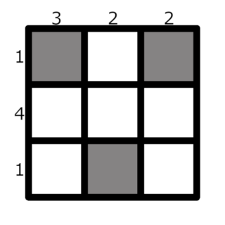White squares are empty
The total cost of that placement is (1+3)+(1+2)+(1+2)=10(1+3)+(1+2)+(1+2)=10.
Calculate the minimum possible total cost of putting chips according to the rules above.
Input
The first line contains a single integer t� (1≤t≤1041≤�≤104) — the number of test cases.
The first line of each test case contains a single integer n� (1≤n≤3⋅1051≤�≤3⋅105).
The second line contains n� integers a1,a2,…,an�1,�2,…,�� (1≤ai≤1091≤��≤109).
The third line contains n� integers b1,b2,…,bn�1,�2,…,�� (1≤bi≤1091≤��≤109).
The sum of n� over all test cases doesn't exceed 3⋅1053⋅105.
Output
For each test case, print a single integer — the minimum possible total cost of putting chips according to the rules.
Example
input
Copy
4
3
1 4 1
3 2 2
1
4
5
2
4 5
2 3
5
5 2 4 5 3
3 4 2 1 5
output
Copy
10
9
13
24
Note
The first test case of the example is described in the statement.

